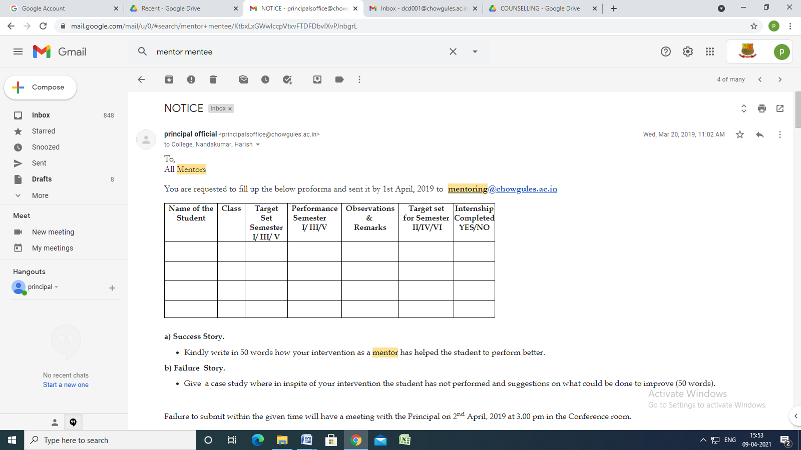

NOTICE
Inbox
principal official <principalsoffice@chowgules.ac.in> | Mar 20, 2019, 11:02 AM
to College, Nandakumar, Harish

To,
All Mentors

You are requested to fill up the below proforma and sent it by 1st April, 2019 to mentoring@chowgules.ac.in

Name of the Student | Class | Target Set  Semester I/ III/ V | Performance  Semester I/ III/V | Observations &  Remarks | Target set for Semester II/IV/VI | Internship Completed YES/NO

a) Success Story.
- Kindly write in 50 words how your intervention as a mentor has helped the student to perform better.
b) Failure Story.
- Give a case study where in inspite of your intervention the student has not performed and suggestions on what could be done to improve (50 words).

Failure to submit within the given time will have a meeting with the Principal on 2nd April, 2019 at 3.00 pm in the Conference room.

PRINCIPAL

MENTOR – MENTEE MEET
22ND March 2019

Name of the Mentor: Ms. Sarita Naik Tari

Name of the Student | Class | Target Set  Semester I/ III/ V | Performance  Semester I/ III/V | Observations &  Remarks | Target set for Semester II/IV/VI | Internship Completed YES/NO
D’Cunha Elroy Daniel | SYBSC | Yes | Following Courses Not cleared  1.Web Designing  2.Digital Logic data |  | Yes | Yes  Goa Rugby  (Sports Organisation)

MENTOR - MENTEE REPORT - ASST. PROF. ANDREW BARRETO

Name of the Student | Class | Target Set  Semester I/ III/ V | Performance  Semester I/ III/V | Observations &  Remarks | Target set for Semester II/IV/VI | Internship Completed YES/NO
MUSKAAN KHAN | FYBA - Sociology | Yes | - | - | NO | NO
SAKHALKAR NEHAL AMOL | SYBA - English | Yes | good | - | Yes | NO
CARDOZO SHAMIN VALLANKA | SYBA - English | Yes | good | - | Yes | NO
KHANDEKAR SARAH RUPESH | SYBsc - Biotechnology | Yes | good | - | Yes | NO
PATIL DHANASHRI MAHESH | SYBsc - Chemistry | Yes | good | - | Yes | NO
RAVEDAR SURTHI MAHADEV | SYBsc - Biotechnology | Yes | good | - | Yes | NO
BARRETTO DEXTER JULIO | SYBsc - Zoology | Yes | good | - | Yes | NO
BANDEKAR RAVEENA PRAKASH | SYBsc - Mathematics | Yes | good | - | Yes | NO
NAVEEN HARI | TYBA - Economics | Yes | good | - | Yes | YES
NAIK AKSHADA GUNDU | TYBA - Hindi | Yes | good | - | Yes | YES
CASTELLO BRULYNN RONISHKA | TYBA - English | Yes | Skipped courses | Left college | NO | NO

Name of the Student | Class | Target Set  Semester I/ III/ V | Performance  Semester I/ III/V | Observations &  Remarks | Target set for Semester II/IV/VI | Internship Completed YES/NO
GAMA SELISTON | TYBsc - Physics | Yes | good | - | Yes | YES
NADAF SHABANA RAMAJAN | TYBsc - Botany | Yes | good | - | Yes | YES
NAVELKAR PAVAN GURUDAS | TYBsc - Zoology | Yes | good | - | Yes | YES
CHAUDHARY SUMAN | TYBsc - Chemistry | Yes | good | - | Yes | YES
ALBUQUERQUE NINOUSKHA MARY CLARINA | MA Part I - English | Yes | good | - | NO | NO
SHAIK SABENAA | FYBVoc - Software Development | Yes | ok | - | Yes | NO

a) Success Story.
- Kindly write in 50 words how your intervention as a mentor has helped the student to perform better.
b) Failure Story.
- Give a case study where in inspite of your intervention the student has not performed and suggestions on what could be done to improve (50 words).

Dr. Sanjay D. Gaikwad
Department OF Geography
Performa of Mentors Mentee Meeting
Name of the Student | Class | Target Set  Semester I/ III/ V | Performance  Semester I/ III/V | Observations &  Remarks | Target set for Semester II/IV/VI | Internship Completed YES/NO
Pooja Talwar | TYBSC | 60 | 60 | No Back log | 65 | YEs
Megan Demalo | FYBSC Zoology | 50 | 50+ | Stat ppr Diff  Back log for PA-Diversity Sem. II | 50 | After Sem. III in Pathology
Shruti Barve | FYBSC (Chem.) |  |  | Had one back log cleared in retake | 50 | In contact with Vasant

Name of the Student | Class
Pooja Talwar | TYBSC | Banking entrance (Po), MSC
Megan Demalo | FYBSC Zoology | Likely to have back in practical Assessment in Diversity ,  Missed some session during Tathastu event
Shruti Barve | FYBSC (Chem.)

a) Success Story.
Pooja Talwar of TYBSC achieved her target has no Backlog and also completed her internship
Shruti Barve of FYBSC (Chem.) had one back log she cleared it in retake
Exam.

b) Failure story.
Megan Demalo of FYBSC Zoology achieved her target need improvement in one paper and likely to have backlog in one practical paper in this sem.
In spite of all several student didn’t turn up for meeting.

MENTOR-MENTEE MEET HELD ON 22nd MARCH 2019
Mentor: Cinderella Bhandare Sequeira

Name of the Student | Class | Target Set  Semester I/ III/ V | Performance  Semester I/ III/V | Observations &  Remarks | Target set for Semester II/IV/VI | Internship Completed YES/NO
Kimberley Fernandes | FYBSc.  SU180331 | Yes (40%) | Cell Biology  Paper cleared in the second attempt | Tendency to set a low target.  Plans to continue her studies abroad in the following semester. | 60% | No
RatishNaik | FYBSc.  SU18191 | 50% | Cleared Semester 1 in the first attempt | Overall percentage is 60% | 50% | No
KenishaFernandes | FYBSsc.  AU180103 | 60% | Semester 1 Statistics not cleared | Not yet answered the repeat exam. | 60% | No
Success Story – Most of my mentees have not been present for the mentor-mentee meet. Those who have approached me have not shared concerns that require my intervention.
Failure Story – As evident in the above table, three of my mentees have not managed to clear semester one in the first attempt. Venica Dias and Kenisha Fernandes did not apply for the re-exam despite my guiding them to do the same.

